Times of India Web Scrapping

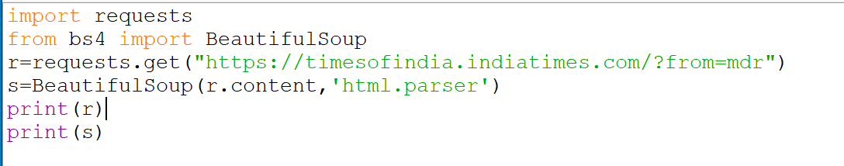

output

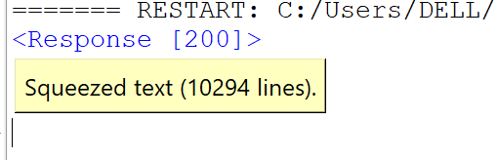

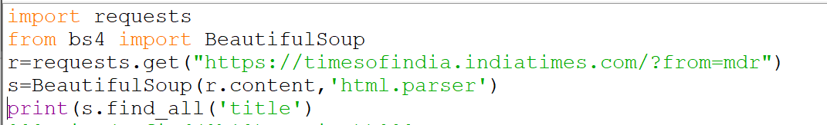

output



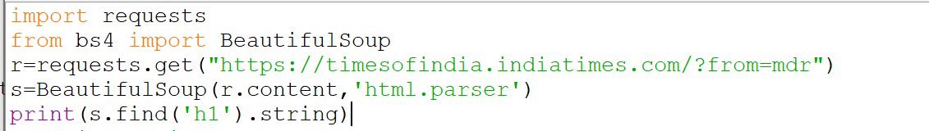

Output

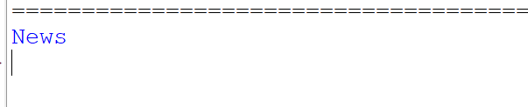

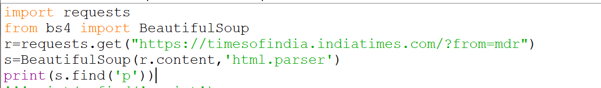

Output

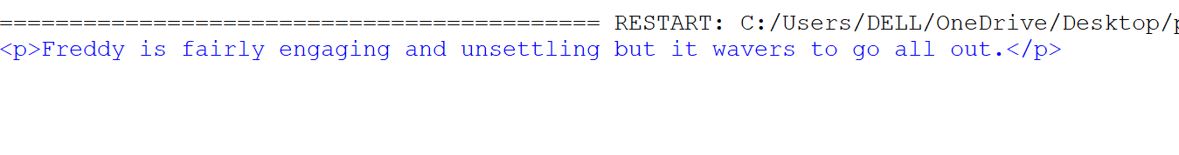

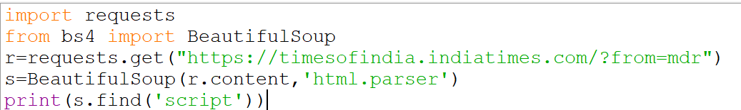

Output

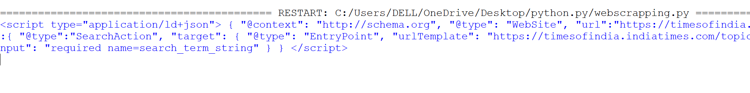

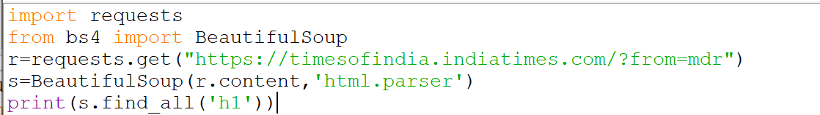

Output

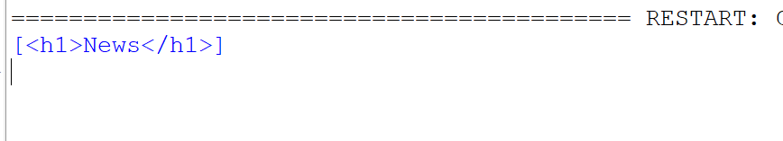

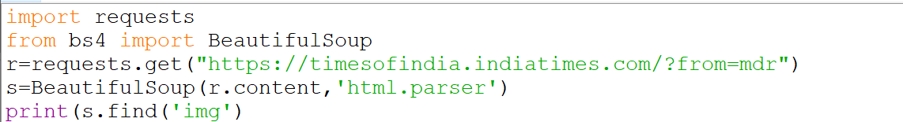

Output



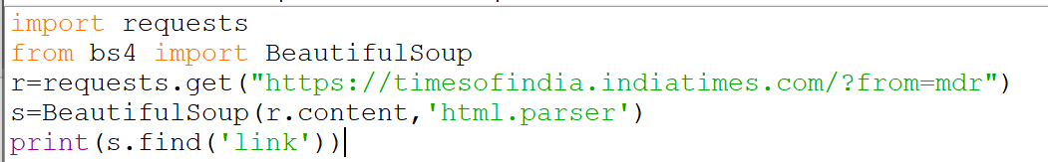

Output

